Part 1 Application – Introduction and Applicant Information

Introduction

The Georgia Environmental Finance Authority (GEFA) invites eligible Georgia water systems to apply for water loss technical assistance from the federal Drinking Water State Revolving Fund. Eligible water systems include:
- Systems that serve 3,300 to 100,000 individuals, and
- Systems that submit a certified 2016 water audit to the Georgia Environmental Protection Division (EPD) by March 1, 2017.
GEFA reserves the right to consider applications for systems that do not meet the certified water audit submittal deadline. The size and number of projects completed through this technical assistance program will be determined based on the number of applicants and available funding. For more information on the Phase IIC technical assistance program, please visit www.gefa.georgia.gov.
Submittal Process

- Complete application and compile all supporting documentation noted on this application.
- Submit the completed application with all supporting documents by March 14, 2017, at 5:00 p.m. EST.
  - By email: larry.lewison@cavanaughsolutions.com.
  - If email submittal is not feasible, contact us directly and we will work on an alternate submittal mechanism.

Please fill out the following information completely. If you have questions regarding this application, you may call 1-877-557-8923 or email larry.lewison@cavanaughsolutions.com.

Utility name
Water system ID #
Key contact person |  |  |  | Title
Street address or P.O. Box
Street address 2
City and zip code |  |  |  |  |  |  | County
Telephone number |  |  | Fax number
Primary email address
Alternate contact person
Alternate telephone number
Alternate email address

If the data requested on this form is not fully available at the time of application, provide as much as possible. We can work with you to obtain any missing information if you are approved for the program.

Part 2 Application – Project Information
Available Project Types
- Finished Water Meter Testing
Hydraulic flow verification of finished water meters (FWMs).
- Customer Water Meter Testing
Accuracy testing of select mid and large size customer meters.

- Pilot Leak Detection
Acoustic leak detection of a portion of the distribution system. Applies to distribution mains (<12”).

- Large Diameter Condition Assessment and Leak Detection
Applies to transmission mains (>12”).

- Pilot District Metered Area (DMA) Evaluation
Evaluation of feasibility for implementing a pilot district metered area.

- Pilot Pressure Management Evaluation
Evaluation of feasibility for implementing a pressure management pilot zone.
Site Specific Information
Place a check mark in the space(s) next to the project type(s) for which you are applying. If you check more than one project type, you must provide your preference ranking (1 is highest preference, 6 is lowest preference).
Project Type | Rank (1-6)
Finished Water Meter Testing ☐
Customer Water Meter Testing ☐
Pilot Leak Detection ☐
Large Diameter Condition Assessment and Leak Detection ☐
Pilot District Metered Area Evaluation ☐
Pilot Pressure Management Evaluation ☐
On the following pages, complete the site specific data sheet on each project type for which you are applying.

Part 3 Application – Project Type Data Sheets
- Finished Water Meter Testing Data Sheet
Please fill out a Finished Water Meter Testing Data Sheet for each finished water meter for which you are applying. If the data requested on this form is not fully available at the time of application, provide as much as possible. We can work with you to obtain any missing information if you are approved for program.

Existing Conditions:
1a. Finished water meter (FWM) identifier number (used to distinguish between multiple meters)

1b. Size of existing meter: | 1c. Type of existing meter (Turbine, Venturi, Magmeter, etc):
1d. Piping configuration
Distance upstream to nearest fitting* (ft)
Type of upstream fitting*
Distance downstream to nearest fitting* (ft)
Type of downstream fitting*
Pipe material
Pipe outer diameter (in)
Total length of pipe between pump and FWMa
Straight length of pipe upstream of FWM^{b}
Straight length of pipe downstream of FWM^{b}
*A fitting would include a tee, elbow, reducer, strainer, valve, and any other appurtenance that may cause turbulence in the flow.

ªThe total length of the pipe, including all joints, fittings, and valves, from the discharge side of the nearest pump to the FWM.
^{b}The straight length of pipe with no flow disturbances can include couplings and sleeves. In general, flow disturbances include fittings with bends, tees, and valves of any type.
1e. Make, model and age of existing meter(s):

1f. Date of last flow verification test (if any):

1g. Date of last electronic calibration (if any):

1h. Other notes or special considerations: (Do you have high service pumps?) (Are your pumps VFD or single-speed drive?)

Please also attach the following information, if available, for each finished water meter for which you are applying.
- Historical water supply data:
  - Indicate the method of measuring or recording the water volume or flow rate for each FWM.
  - Provide a minimum of one year of data to determine the annual flow patterns.
  - For volume based records, provide the pump schedule.
  - Whenever possible, provide average flow at one hour intervals or the next shortest measurement available.
- Photographs of each meter to be tested
- Field measurements and a piping configuration exhibit with pipe sizes and valving (see Exhibit A for example)
- Documentation from last flow verification test or electronic meter calibration, if available

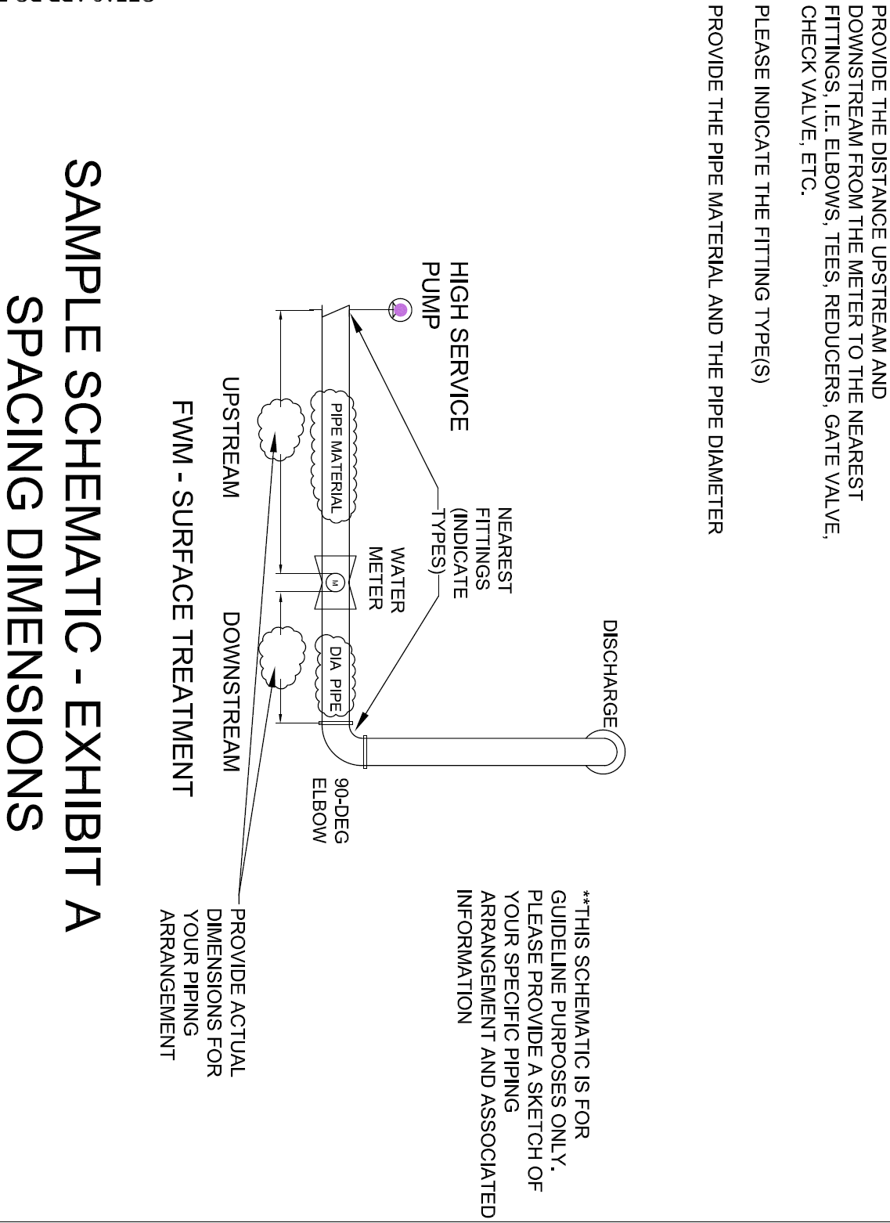

- Customer Water Meter Testing Data Sheet
Please fill out Customer Water Meter Testing Data Sheet and attach requested information. If the data requested on this form is not fully available at the time of application, provide as much as possible. We can work with you to obtain any missing information if you are approved for program.

Existing Conditions
2a. Any known maintenance issues for your customer meters (2” and larger), such as access restrictions, inoperable shutoff valves, or other issues that may limit their testability?

Please also attach the following information:
- A listing of all 2” and larger customer meters including the following information for each meter (Excel format preferred):
  - Meter identification number
  - Meter address
  - Meter Size
  - Usage history (total for past 12 months; see Exhibit B for example)
  - Manufacturer (if available)
  - Meter type, i.e., compound, turbine, positive displacement, multi-jet, magmeter, propeller
  - Installation date
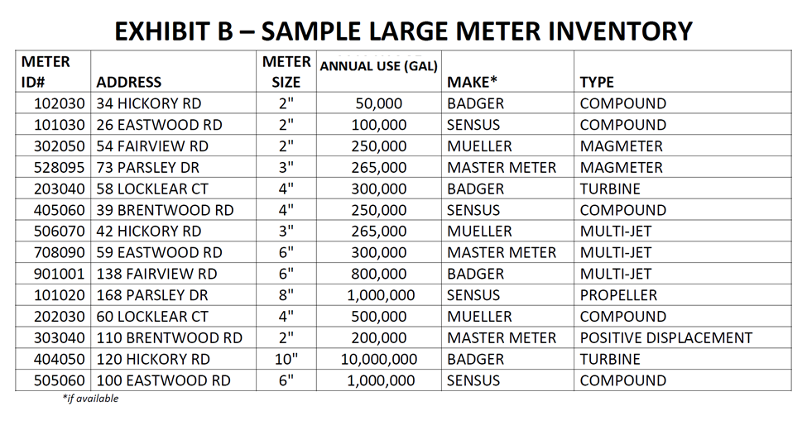

- Pilot Leak Detection Data Sheet
Please fill out a Pilot Leak Detection Data Sheet and attach requested information. If the data requested on this form is not fully available at the time of application, provide as much as possible. We can work with you to obtain any missing information if you are approved for program.

Existing Conditions
3a. Fill in approximate percentages of pipe material for your distribution system:

Pipe Material Type | Percent of the system
3a-1. DIP –
3a-2. CIP –
3a-3. PVC –
3a-4. AC –
3a-5. Galvanized –
3a-6. Other –

3b. How many miles of water main are in the system?

Please also attach the following information, if available:
- A summary of historical leak repairs, as available
- Mapping of the distribution system containing:
  - Valve and hydrant locations
  - Highlighted known areas of concern
  - Pressure zones delineated (if known)

*It is understood that mapping quality, completeness, and format varies among systems. Provide the best mapping available.

- Large Diameter Condition Assessment and Leak Detection Data Sheet
Please fill out a Large Diameter Condition Assessment and Leak Detection Data Sheet and attach requested information. If the data requested on this form is not fully available at the time of application, provide as much as possible. We can work with you to obtain any missing information if you are approved for program.

Existing Conditions
4a. How many total miles of main are in the water system?

4b. How many miles of main of pipe >12”?

4c. Fill in approximate percentages of pipe material in your distribution system, >12”:

Pipe Material Type | Pipe diameters (inches) | main length (miles) | approximate age (years)
4c-1. DIP
4c-2. CIP
4c-3. Steel
4c-4. Concrete
4c-5. PVC
4c-6. PE
4c-7. AC
4c-8. Other

Please also attach a map of pipe containing line sizes >12”, with line size designations.
4d. Other relevant information on transmission mains.

- Pilot District Metered Area Evaluation Data Sheet
Please attach the following information, if available. If the data requested on this form is not fully available at the time of application, provide as much as possible. We can work with you to obtain any missing information if you are approved for program.

- Paper mapping of the distribution system*
- GIS shapefiles, if available:
  - Tank and pump station locations
  - Waterlines
  - Valves (particularly valves that are currently closed)
  - Pressure zones delineated
  - Water treatment plant(s)
- Inventory of major customers
- Inventory of critical customers, i.e., hospitals, dialysis patients/centers, etc.
- Inventory of water storage tanks with capacity and identifier (name, address, etc.)
- Inventory of pump stations
- Does your utility have a recently calibrated (last five years) hydraulic model?

*It is understood that mapping quality, completeness, and format varies among systems. Provide the best mapping available.

- Pressure Management Data Sheet
Please attach the following information, if available. If the data requested on this form is not fully available at the time of application, provide as much as possible. We can work with you to obtain any missing information if you are approved for program.

- Break repair history for the past five years, including: location, repair type (main versus service), line size, material, date of repair, pressure zone
- Leak detection history
  - What areas were surveyed, during what timeframe, and number of leaks found?
- Mapping of the distribution system containing*:
  - Tank and pump station locations
  - Waterlines
  - Valves (particularly valves that are currently closed)
  - Pressure zones delineated
  - Water treatment plant(s)
- A separate water system map with elevations
- Inventory of water storage tanks with capacity and identifier (name, address, etc.)
- Inventory of pump stations
- Available pressure data (from hydrant flow tests, SCADA, or pressure logging)
- Inventory of major customers
- Inventory of critical customers, i.e., hospitals, dialysis patients/centers, etc.
- Does your utility have a recently calibrated (last five years) hydraulic model?

*It is understood that mapping quality, completeness and format varies among systems. Provide the best mapping available.

