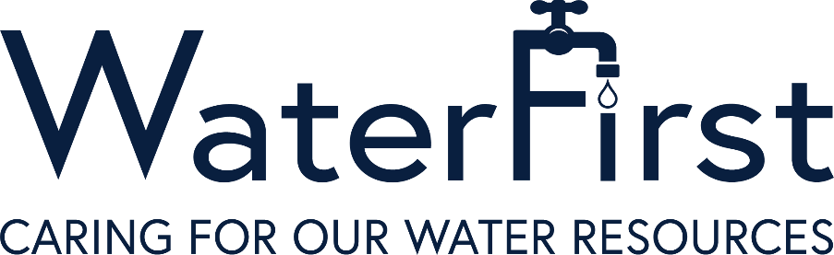

Georgia Environmental Finance Authority
WaterFirst Program Renewal Application

The WaterFirst Program is a voluntary partnership between local governments, state agencies, and other organizations working together to increase the quality of life in communities through the wise management and protection of our valuable water resources. This proactive approach to water resources requires local governments to make the connection between land use and water quality, and it requires thinking beyond political boundaries to recognize the inextricable links created by shared water resources. The intended result of WaterFirst is achieving excellence beyond the current water regulations in nine major categories:

- Watershed assessment,
- Stormwater master planning,
- Wastewater treatment and management,
- Water supply planning,
- Water supply protection,
- Water conservation,
- Water reclamation and reuse,
- Educational outreach; and
- Regional water planning.

To continue qualifying for WaterFirst incentives, communities must be recertified every five years. It has been five years since your designation or renewal. GEFA needs to evaluate your programs to ensure that your community is still achieving environmental excellence. If you have questions regarding this renewal application, please contact waterresources@gefa.ga.gov.

Renewal Application Deadline

The deadline for submitting the renewal application is the last business day of October.

Please submit one digital copy of the application to waterresources@gefa.ga.gov.

I. Applicant Information

Please check one:  Individual City or County or  Multi-Jurisdictional Partnership

City/County of: __________________________________________________________

Address: ________________________________________________________________

City: ________________________________________ Zip Code:_________________

Phone: __________________________ Fax: __________________________

Email: _________________________________________________________________

Name of Person Completing Application: ______________________________________

Title: ___________________________________________________________________

Address: ________________________________________________________________

City: ________________________________________ Zip Code: _________________

Phone: __________________________ Fax: __________________________

Email: _________________________________________________________________

II. Community Profile

(If applying as a partnership, please answer the following questions for each partner, separate pages may be added.)

Are you currently a Qualified Local Government?

In what water basin(s) are you located?

Have your water services that were provided at designation changed? If so, how?

Has your service area changed? If so, how?

How many residents does each service support?

Has the percent of residents using private wells, septic systems changed? If so, how?

Has your primary water source for your community changed (surface/groundwater)?

In comparison to five years ago, what are your water conservation savings?

In the past five years, have you received a GEFA loan, 319 grant, and/or CDBG funding? If so, what financial savings/amounts have your received?

Please list your community's current water-related EPD permits.

Please list any EPD water-related permit violations that have occurred in the past five years. Please give details of how the violations were addressed.

Have any 303(D) listed streams been delisted in the past five years? If so, what stream(s)?

In the past five years, have you received any awards for outstanding water services?

In the past five years, have there been any permits or regulatory minimum standard changes? If so, how were they addressed?

Is your community on EPA's Significant Non-Compliance list? If so, please explain.

Are there any other benefits you have received since designation?

Report on your MOU goals from the past five years:

What are your WaterFirst goals for the next five years?

Attached is your checklist at the time of your original application. Please update the checklist and explain any significant changes in the past five years.

I understand that the WaterFirst Community Program is a voluntary effort to improve the management and protection of our water resources beyond the requirements of the law. I also understand that WaterFirst designation can be lost if the community fails to maintain the achievements for which the award was given and that all benefits the designation brings with it will be forfeited.

I certify to the best of my knowledge that the information in this application is true and correct.

Print name of Chief Elected Official __________________________________________

Signature of Chief Elected Official ___________________________________________

Date ______/_______/_______

